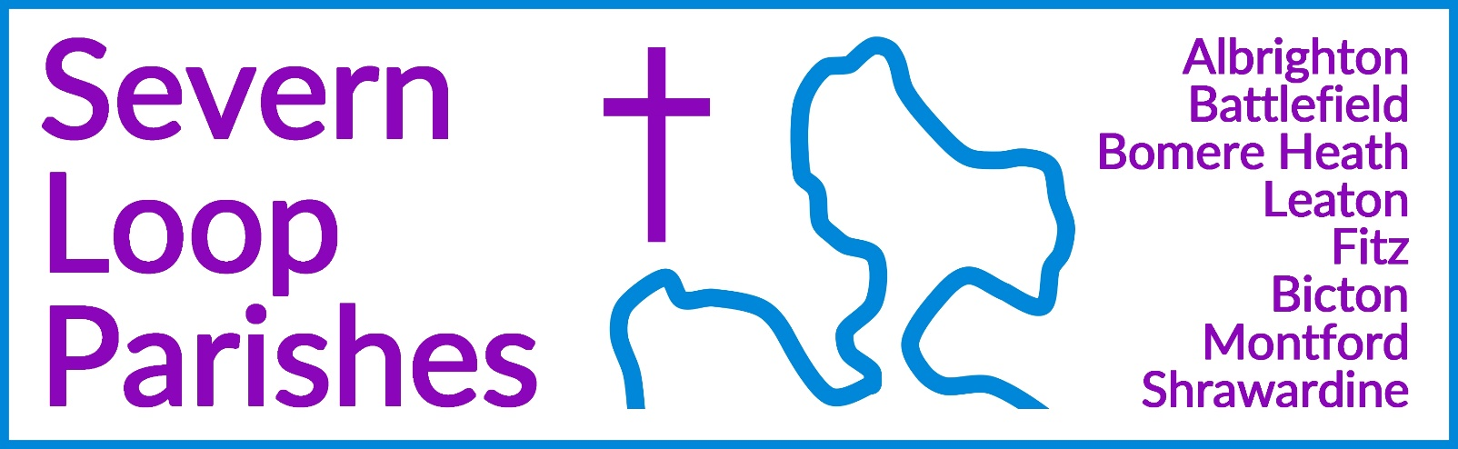
Priest in Charge: | Revd Hannah Lins | revhannahlins@gmail.com, 07736 012011
Assistant Priest: | Revd Peter Allan | pallan412@gmail.com, 01939 290048
Pastoral Minister: | Mrs Joyce Jagger | pearhill1@outlook.com, 07802 695954
Safeguarding Officer: | Mrs Philippa Herbert | 07871 865253
Administrator: | Miss Rosie Dixon | severn.loopparishes@gmail.com
Daily Hope (the national phoneline service) |  | 0800 8048044
Weekly Collects, readings and reflections are on the website- www.severnloopparishes.org.uk |  | 
JUNE LOOP 2025
Welcome to Dave!

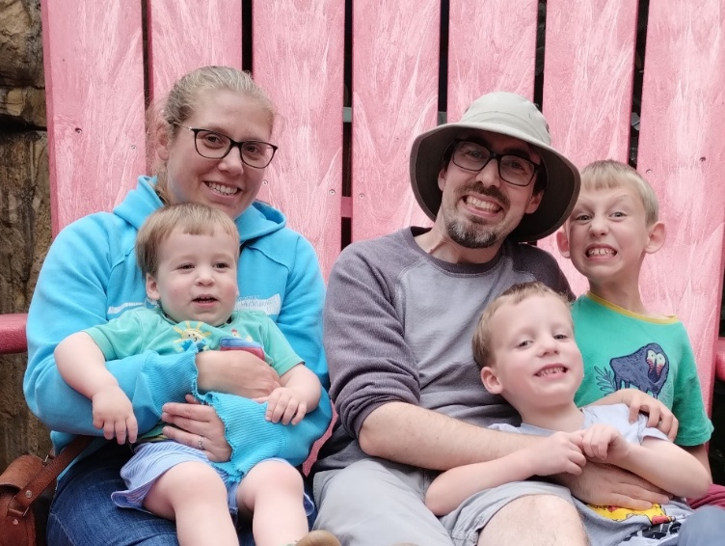
The day is nearly upon us! Dave Latcham, our new curate, will be joining us at the end of June. His ordination in Lichfield will be on Saturday, 28th June, 6pm. The next morning is his welcome service- 10.30am, Fitz, followed by lunch in Fitz Village Hall. We are very much hoping that plenty of people will attend to give Dave and his family a hearty welcome!

Please keep Dave, Sarah, Marty, Jago and Gilbert in your prayers as Dave continues to prepare for the next step and join us in Severn Loop.


Ladies afternoon tea.
14th June 3pm
Mission Church. In Bomere Heath
Speaker Father Peter Allan.
Tickets from 290647 or 290604
£7.

Graveside Service at Montford

Join us for a brief and simple graveside service to remember loved-ones in Montford Churchyard. Our service will be followed by refreshments in church. Gather in the churchyard at 11.55am on Sunday, 22nd June.

Forest Church
Our next Forest Church will be on the13th of July, 3pm, in the churchyard at Bicton. Local expert, Sue Dancey, will be with us to help us explore the wildlife. We’ll also be planting a shared herb garden, do some seasonal crafts and possibly have a try at maypole dancing! All are welcome.
Diary Dates
CAMEO Coffee Morning at Bicton Church- 12th June, 10.30am-11.30am.
The Stepping Out Café in Bomere Heath- 25th June, 2.30pm-4pm
Filling Station- Knockin Village Hall is on 17th June, 7.10pm for a 7.30pm start. The next one at Rodington Village Hall (SY4 4QS) is on 23rd June, 2025, 7.15pm for a 7.30pm start.
Deanery Synod- Wednesday, 25th June, 7pm for 7.30pm, Oxon Church.
REVS- Saturday, 21st June, 10am-noon, Holy Trinity, Leaton.

For Your Prayers
- For our local farmers.
- For peace.
- For children and young people doing exams.
- For Forest Church and our ministry to children.
- For those in hospital, and for our NHS.
- For those who are bereaved, particularly the family and friends of Nico Stephens, Prue Quayle, Judy King, Charlotte Vincent and Trevor Davies.

Readings for June

Date | Psalm | First Reading | Second Reading/ Gospel
1st June  Easter 7, white | Psalm 97 | Acts 16. 16-34 | John 17. 20-26
8th June  Pentecost, red | Psalm 104  26-36, 37b. | Acts 2. 1-21 | John 14. 8-17
15th June  Trinity Sunday, white | Psalm 8 | Romans 5. 1-5 | John 16. 12-15
22nd June  Trinity 1, green | Psalm 22. 19-28 | Galatians 3. 23-29 | Luke 8. 26-39
29th June  Trinity 2, green | Psalm 16 | Galatians 5. 1, 13-25 | Luke 9. 51-62
6th July  Trinity 3, green | Psalm 66. 1-8 | Galatians 6. 1-16 | Luke 10. 1-11, 16-20

SUNDAY SERVICES FOR JUNE 2025

 | Albrighton | Bicton | Bomere  Heath | Fitz | Leaton | Montford | Shrawardine
1st June | 9.15 am  HC | 6pm  RBL |  | 9.30 am  MP | 10.45 am  HC |  | 9.30 am  MP
8th June |  | 11am  MP | 9 am  HC |  | 10.45 am  MP | 9.30 am  HC | 11 am  HC
15th June | 9.15 am  MP | 11 am  HC |  | 9.30 am  HC | 10.45 am  HC | 9.30 am  MP
22nd June |  | 11 am  MP | 9 am  HC |  | 10.45 am  MP | 11 am  HC | 9.30 am  HC
29th June |  |  |  | Welcome service for David Latcham, followed by lunch. 10.30am
6th July | 9.15 am  HC | 11 am  HC |  | 9.30 am  HC | 10.45 am  HC |  | 9.30 am  MP

HC- Holy Communion; MP- Morning Prayer
OTHER WAYS TO WORSHIP ON SUNDAYS- SUNDAY AT SIX 6 pm via Zoom – email Peter or Hannah to receive the link. DAILY HOPE – national phone line, see number above. LICHFIELD CATHEDRAL- www.lichfield-cathedral.org 10.30 am Eucharist



