
Bomere Heath & District Parish Council is on Facebook - www.facebook.com/pg/BomereHeathCouncil
BOMERE HEATH PARISH COUNCIL
There is always an open invite to members of the public, should you like to attend as a member of public you are very welcome, but spaces can be limited. If so, please contact the clerk to book a space.

Below are extracts from the Parish Council meetings at Bomere Village Hall on Wednesday 11th Sept 2024 and extracts from the summer.

Community News

Police NEWS

West Mercia Police keep us up to date and have attended several PC Meetings this summer.

We are aware that to be vigilant for suspicious behaviour, with opportunist shed thefts. Should you see anything, please dial 111 and if possible, try and gain registration numbers of vehicles or a description of cars and people (ONLY If it is safe to do so).

Similarly, the Parish Council has been advised of near misses on our roads, many of these go un-recorded. This data is extremely important and ideally to be passed to the PC or the Police, again with as much detail as possible. (Date/Time/Location & a brief description – ideally with photos) When we are discussing road safety in the future, data is important in getting the authorities to consider with all the information.


Shropshire Council

The Public Space Protection Order (PSPO) to address dog fouling and nuisance took effect on 1 June this year.
Fly Tipping We are working with colleagues within West Mercia Police, Defra, The Environment Agency and other Local Authorities to gather evidence and share best practice in how to tackle this issue. We will make use of CCTV cameras and signage where possible to reduce opportunities for fly tippers to dispose of waste across our county. If you would like to report an incident of fly-tipping, you can do so via FixMyStreet.
Garden Green Waste - Householders wanting to have their garden waste bins emptied after 1 October [2024] can subscribe to Shropshire Council’s garden waste service from today (Tuesday 3 September).
A 12-month subscription costs £56 per bin and will cover the period 1 October to 30 September. Garden waste collections will stop from 1 October 2024 for anyone that hasn’t subscribed by this date.
A payment window will be open until 31 March 2025. To subscribe and for more information about the service people should visit the Shropshire Council website at www.shropshire.gov.uk/gardenwaste.

Anyone unable to subscribe and pay online can call 0345 520 7007.
Fraud & text Scams – Be aware of a hack at Telford & Wrekin Carpark system – Texts being sent claiming that they have a “Parking Penalty Charge Noice” and gives 28 days to respond. The scam is to get users to click on a link to avoid a fine. The link is fake and not connected to Telford or Shrewsbury Councils.

Planning
We reviewed several applications since the last publication.
Full Feedback can be found on the Shropshire Planning Portal.

Finance
The PC has healthy finances, we have increased the budget for administrative in this term to align for future increases and the spending is being reviewed monthly.

BH Play Park
We have been informed through our inspections that there are some repairs needed at the Play Park. We have been in touch with maintenance contractors and the PC agreed to pay for the repairs and upkeep to the equipment.

Grant Funding
The PC has approved a grant for the 2 Village Halls to receive large flat screen TV’s and stands to use. The plan is part of our paperless objective and allow the PC to function better in the meetings and the community will be able to benefit from their use.

Youth Club
The group as a whole love physical activity particularly football. Most of the group at the moment are boys with a few girls.
Sport is being used to promote teamwork and communication and can also challenge preconceptions. The young people have also played other team games such as Dodgeball and Capture the flag. Table tennis is always popular as is Badminton.
The group have also looked at healthy foods. Fruit kebabs went down well. More fruit was requested alongside the tuck shop sweets. The young people have also looked at cooking and preparing their own food.

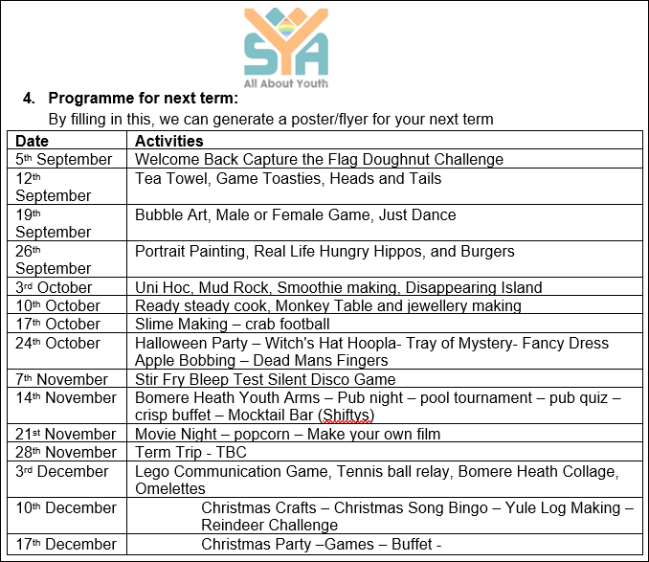

Resignation –
This month we have received the resignation from cllr Keoh. We wish to thank Mick for all his hard work on the PC for the last 8 years.

Should anyone like to join the PC we would welcome your interest.
---------------------------------------------------------------------------------------------------------------------------

The next meeting is to be held on Wednesday 9th October 2024 at 7.30pm in Bomere Heath Village Hall.

We will post the agenda for this meeting on the website nearer the time. If you wish to have a comment read aloud on an issue, please contact the Clerk in writing and give 5 working days’ notice so it can be placed on an Agenda. clerk@bomereheath.co.uk

