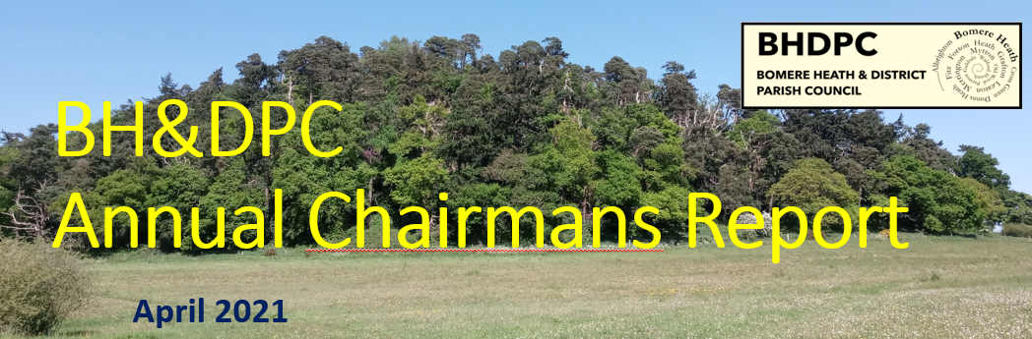
April 2024
Chairman’s Report – April 2024.
Last AGM I set our goals for 2023 focusing on the following.
- Environment,
- Progress
- & Wellbeing

I think the PC continue to make positive steps to boost and benefit our environment. We have continued to seek opportunities to promote and encourage

Once again, I wish to thank the Parish Council for its efforts during the last 12 months. As a parish council we have covered many key items, such as

Youth Club – The youth club is continuing and in a good place. The PC have committed to fund both the SYA assisted programme, the Village Hall hire costs and this March issued a Grant to allow them to purchase some games and equipment.

Village Halls – We continue to support to the Fitz and BH Village Halls in their ventures and with maintenance for the more costly items.
We have assisted Fitz with a planning application and contribution funding the purchase of the land for an extended carpark and external space. The Village Hall will likely need further funding to support the anticipated works on the land.

Local Developments – The PC has been involved in the planning process, objecting to the 19 affordable homes to the North, and working closely with the planners & the developer to work through issues and details that we felt needed to be addressed. Through this engagement the developer has revised their drawings and proposals and also has offered to aid the PC in providing a facility for the older youth in the parish.
Whilst I acknowledge that some of the PC planning decisions have not been favoured by the community, we always have the community best interests at the forefront of our decision making process and review applications within the parameters of Material Conditions.

Play Park – The play park has been on the PC agenda as always. The play park and namely complaints associated with the park have reduced significantly this year. The PC has tried to encourage appropriate usage so that the park and local residents can exist in harmony.
One of the offers from the Estate to the south is that this will now provide a second play park that will serve the south of Bomere Heath and hopefully relieve the pressure on our existing park.
As part of wider discussions, the PC are hoping to acquire land to allow the provision of a football/BMX/general older play space. This will be a slow process buy the nature of planning/land acquisition and legal works/installation of whatever we agree on. Therefore, a longer-term goal for the PC.
A matter of the Ball Park at the Primary School was raised and a public calling for the PC to re-open the Ball Park. We clarified that the Ball Park is a private entity owned by the school and the PC has no ability to action this, hence the investigations in an alternative facility.

Bus Stop- I thank Cllr Keogh for his continued work on the bus stop on the Merrington Rd opposite Brook Rd. The Bus stop is now up and running.

The Parish Council has reviewed many planning applications during the last 12months.
I will advocate that the PC follow applications post completion and ensure that drawings and plans are completed in line with the application and areas that developers are due to maintain are completed.

I am pleased to report that the Finances of the Parish Council are strong, the PC finance committee met in March to monitor against the 2023/4 budget and set next years targets.

The PC precept has been increased by 5% to factor in the cost increases and inflation in general. This means that the running cost outgoings are more than the incomings, but the finances can support this

We do have a modest sum set aside in our annual budget for local community groups/activities/events funding. Should there be a requirement for financial assistance, please fill in the grant application form on our website and email the clerk for us to consider.

& Forton Heath EOI – Unfortunately this has not been concluded in the year. We will continue to press SCC and Highways to agree a strategy and get the funding and the works into action.

In closing, I would like to thank.
Shropshire Cllr Lezley Picton for her continued support throughout the year.
And as always, our Clerk Sue Horton for her hard work in assisting and supporting the PC.

Lastly, I thank the parishioners, those that engage with the Parish Council and interact are very helpful. It is sometimes hard to make decisions with the best interest of the Parish, this is made much easier when we have an idea of what is important to you. We continue to encourage your feedback, both positive and negative where appropriate. Your feedback and interaction are valued and hopefully our actions reflect the majority view in the parish.

Many Thanks
Dan Harmer
Chair – Bomere Heath Parish Council

