
Bomere Heath & District Parish Council is on Facebook - www.facebook.com/pg/BomereHeathCouncil
BOMERE HEATH PARISH COUNCIL
There is always an open invite to members of the public, should you like to attend as a member of public you are very welcome, but spaces can be limited. If so, please contact the clerk to book a space.

Below are extracts from the Parish Council meetings at Bomere Village Hall on Wednesday 9th Oct 2024.

Community News

Police NEWS

We are aware that to be vigilant for suspicious behaviour, with opportunist shed thefts. Should you see anything, please dial 111 and if possible, try and gain registration numbers of vehicles or a description of cars and people (ONLY If it is safe to do so).

Similarly, the Parish Council has been advised of near misses on our roads, many of these go un-recorded. This data is extremely important and ideally to be passed to the PC or the Police, again with as much detail as possible. (Date/Time/Location & a brief description – ideally with photos) When we are discussing road safety in the future, data is important in getting the authorities to consider with all the information.


Shropshire Council

Garden Green Waste - Householders wanting to have their garden waste bins emptied from 4th November [2024] can subscribe to Shropshire Council’s garden waste service at www.next.shropshire.gov.uk/recycling-and-rubbish/garden-waste-collections/
A 12-month subscription costs £56 per bin and will cover the period 1 October to 30 September. Garden waste collections will stop from 1 October 2024 for anyone that hasn’t subscribed by this date.
There has been some issues with the QR stickers needed for this service, but this is now being rectified.

Planning
We had no submissions to review. Full details of planning, past & present can be found on the Shropshire Planning Portal.

BH Play Park
The PC has approved the repairs to the play park and these are anticipated to be completed in November.

Grant Funding
The PC reviewed 2 applications and was able to support the Friends of Bomere Heath on a legacy project, support the 2 Village Halls with new 50” TVs for meetings and have started dialogue to work with the Cricket Club for a large-scale drainage project they are working on.

Youth Club
The group hasn’t been able to operate for a few sessions due to the lack of Volunteer numbers. The PC pay for the Hall Hire, the SYA Leader, but the scheme we are on requires a set of volunteers to support each session. If your child attends the Youth Club, please put your name down to support at least 1 session a term and this should solve the issue. Similarly, if you are willing to be involved (even if you have no children at the session) SYA would love to have your support.

The PC cannot afford a fully funded youth club scheme (£10k per year) but cannot justify the part funded scheme (£4,500 per yr) if the sessions are continued to be cancelled. Any assistance would be appreciated, and the PC will review again in March.

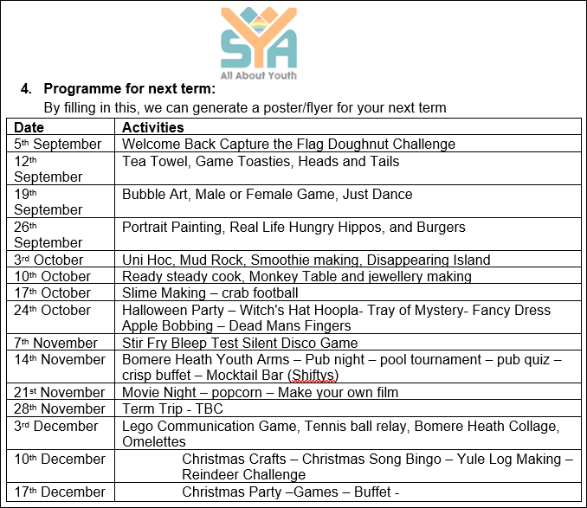

Should anyone like to join the PC we would welcome your interest.
---------------------------------------------------------------------------------------------------------------------------

The next meeting is to be held on Wednesday 13th November 2024 at 7.30pm in Bomere Heath Village Hall.

We will post the agenda for this meeting on the website nearer the time. If you wish to have a comment read aloud on an issue, please contact the Clerk in writing and give 5 working days’ notice so it can be placed on an Agenda. clerk@bomereheath.co.uk

