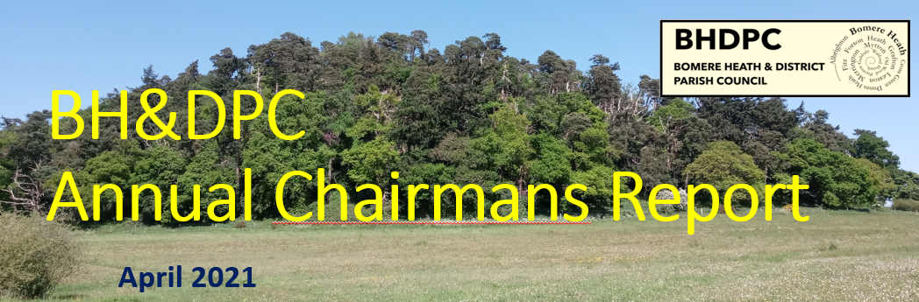
April 2025
Chairman’s Report – April 2025.
Once again, I wish to thank the Parish Council for its continued efforts during the last 12 months. As a parish council we have covered many key items, such as;

Supporting our Village Halls – We continue to support to the Fitz and BH Village Halls in their ventures and provided maintenance for the more costly items.
This year we contributed the £12500 grant to Fitz & 2 TVS for each Village Hall.

Younger persons play facilities – Seeming every few years the Ball Park situation seems to rear its head. There seems to be miss-information or miss-understanding about the detail around the Ball Park at Bomere Heath Primary School. I ask the PC and the wider community to remember that this is private land, and whilst the facilities were contributed to by the PC, the owners of the land and the school were unable to agree lease terms, so the PC gifted the facility to the Primary School, so they could continue to benefit.

A new play facility is very much on the PC agenda as always. The PC is continuing to review land opportunities, and are in talks with local landowners to locate a viable location for a new ball park/bike track/recreational space. We hope that this will progress soon.

Ongoing Maintenance – The play park off Preston Guball’s Rd required the biggest maintenance works, totalling over £3k this year. The first big spend since it was built in 2013. We continue to review and are trying to be proactive and preventative where possible.

Land on Broomhall Lane – The PC has a small slither of land off Broomhall Lane where a former house was located. We agreed earlier this year to review options, including its sale, possibly as a self-build dwelling site. This will take a bit of time but could generate some income and provide a S106 self-build location if agreed by all the relevant authorities.

Forton Heath EOI – Unfortunately another year has passed, and this has not been concluded. Frustratingly, we learned on Monday that another vehicle has left the road colliding with a brick wall in Forton Heath. I have queried with all parties involved, what is the hold up and when will the works start.
Delays to this work are becoming unacceptable and the parties involved should be ashamed at the length of time this process has taken.

Community Events - We have been approached by a committee (who meet tomorrow) regarding a BH Fete, and another group in the village would like contributions to a VE day celebration. It is fantastic that the PC agree to support groups like this that have community spirit at their heart,

I am pleased to say that the trial Severn Trent Green Scheme was a success. There was a high uptake, with positive engagement and ultimately a better network. Thanks to all those who got involved and made the process worthwhile.

Xmas Tree – Once again we give thanks to Leaton Estate for donating the community Christmas Tree, It really makes a difference to the village and can be viewed by all.

The PC has updated the website to have a new .gov secure web address. This also forms part of our GDPR compliance and our data storage system. As part of a cost review, we will also be changing our email addresses. You will see that there are fewer PC contact emails, and the addresses will change very soon. This should save several hundred pounds a year.
As part of the website update, we now host the Parish News on their own page and digital copies of back issues are now available to view.

Youth Club – The youth club has suffered significantly this year with poor volunteer attendance. The PC met with SYA to review our options. The PC have previously committed to fund the SYA assisted programme, the Village Hall hire costs, but this is circa £7k annually. A fully managed club run by SYA, with hire costs, would be circa £12k and the PC are not willing to contribute this amount.
We recognise the need for facilities for the younger people in the community, so agreed to cease the current group, and under the guidance of SYA are trying an alternative group. In May with a new yr 6 only group and starting to grow the year groups from there. The success of this will be entirely reliant on volunteer assistance. Should the group not be sustainable or economic the PC will review and likely that we will withdraw funding and close the group, looking to financially support other youth outlets instead.

The Parish Council has reviewed many planning applications during the last 12months.
I will advocate that the PC follow applications during & post completion and ensure that drawings and plans are completed in line with the application and areas that developers are due to maintain are completed.

It is worth noting that the new housing development phase of 62 houses to the south of BH has started and the 19 to the North of the Village seems imminent.
I do want to reflect on the changes to the planning laws and the impact that could be bestowed upon our community. It is very likely that Bomere will have further development, but the community needs to identify where would be most palatable and what this should look like. The PC could be cut out of discussions in the future, and this may impact what additional facilities or infrastructure considerations that we tend to voice on behalf of the community.
The PC is proposing to closely review the new SCC Local Plan and understand the impact to our community. There may be a need for the community to come together the voice it’s thoughts and we may need to lobby our MP if we feel ignored.

I am pleased to report that the Finances of the Parish Council are in a good position, the PC finance committee meets throughout the year to monitor against the budget and set targets.
This year saw the biggest jump in precept for the PC, this was because of a low precept collection starting point, and an increase of just under £12 equated to 44% rise in 2025. It is inevitable that the Precept will rise again, because the income from council tax is less than our expenditure, but we will monitor this closely.

Through early negotiation, we have a contributory £50k CIL levy from the new development to the South of the Village, and will work hard to utilise this on the play park facility.

Running costs have increased - We acknowledge that in an audit report our staff salary was lower that the norm base rate and we needed to take steps to build in resilience and future planning to include significantly increased pension & NI contributions.

As always, the PC retained a modest sum set aside in our annual budget for local community groups/activities/events funding. Should there be a requirement for financial assistance, please fill in the grant application form on our website and email the clerk for us to consider.

In closing, I would like to thank.
Shropshire Cllr Lezley Picton for her continued support throughout the year and wish her a warm and well-deserved retirement. And as always, our Clerk Sue Horton for her hard work in assisting and supporting the PC.

Lastly, I thank the parishioners, those that engage with the Parish Council and interact are very helpful. It is sometimes hard to make decisions with the best interest of the Parish, this is made much easier when we have an idea of what is important to you.

We continue to encourage your feedback, both positive and negative where appropriate. Your feedback and interaction are valued and hopefully our actions reflect the majority view in the parish.

Many Thanks
Dan Harmer
Chair – Bomere Heath Parish Council0

